CATCH Kids Club in Oklahoma
Year 3 Evaluation Summary

Primary Goal: Reduce childhood obesity among participating children
- Increasing fruit and vegetable consumption
- Encouraging children to become more physically active
- Promoting environmental change within the after-school programs

CATCH Kids Club Sites
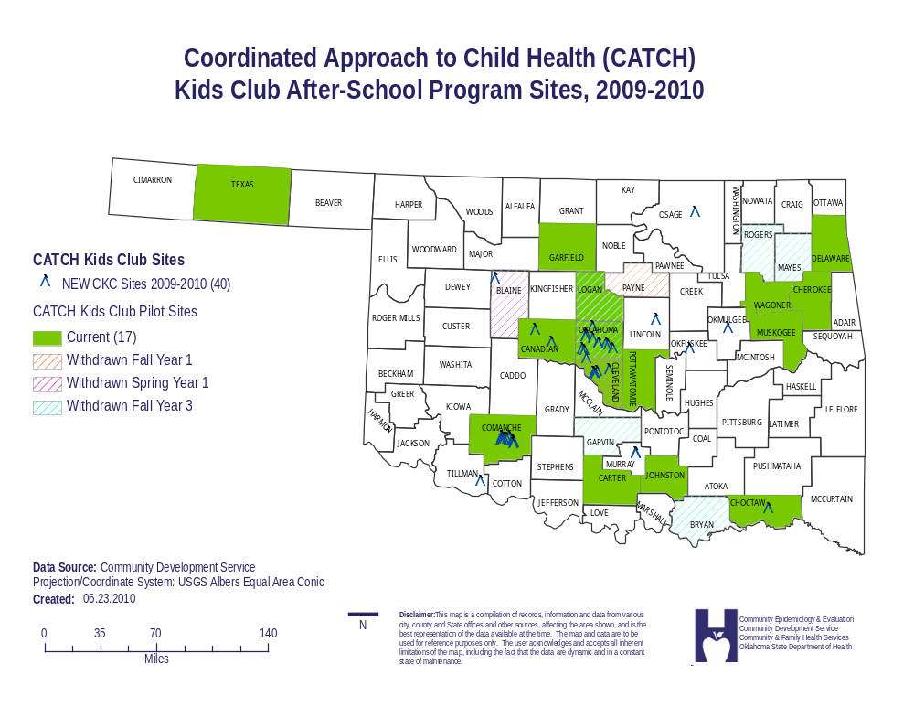
CKC Participation

Table 1: CATCH Kids Club Participation
Year | Semester | Number of Sites | Number of  K-5th graders  (Average per Site) | % in 3rd-5th grade
Year 1 | Fall | 20 | 611 (31) | 55%
 | Spring | 21 | 748 (36) | 51%
Year 2 | Fall | 20 | 757 (38) | 49%
 | Spring | 19 | 580 (31) | 58%
Year 3 | Fall | 16 | 491 (31) | 52%
 | Spring* | 12 | 328 (27) | 54%
*Note: Not all sites reported end of year numbers to date.

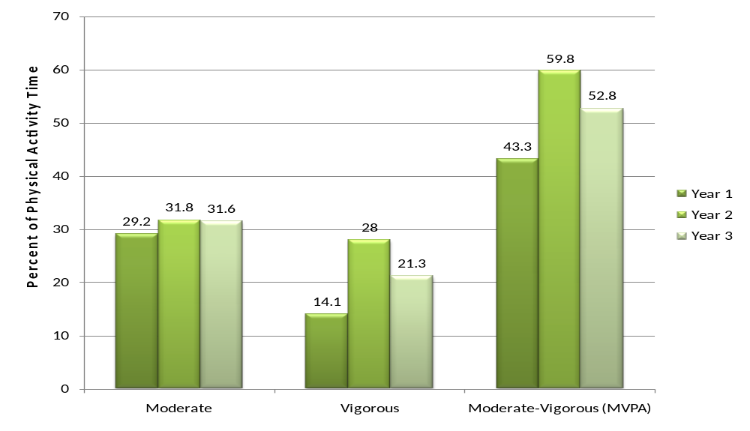Physical Activity Results (SOFIT)

- There was a significant increase in moderate to vigorous physical activity (MVPA) among participants between Year 1 and Year 2 (p-value = .016).
- The decrease in MVPA during Year 3 was not statistically significant (p-value = .32).
- Efforts will be implemented to increase MVPA to 60% of the physical activity time during the 2010-2011 program year across all sites.

Student Survey
CATCH Kids Club programs began with 20 sites as a pilot project in Fall 2007. Evaluation components (student survey and height/weight data collection) were collected before the implementation of the program and at the conclusion of the school year. This process was repeated each year for a 3-year pilot period, through the 2009-2010 school year.
The following report reveals the Student Survey data that was collected from each student present on survey days. There were 54 questions regarding nutrition. Results were calculated using student t-tests comparing pre- and post- data for each year. Individual questions were grouped into five categories: Food Behavior, Food Knowledge, Food Preference, Physical Activity Behavior, and Self Efficacy. Individual question and composite scores are presented below.
Composite scores are displayed in bold. The direction of change is indicated as toward the positive answer or negative answer. For example, if the question asks how many fruits and vegetables did you eat in the previous day, responses with higher fruit and vegetable consumption were weighted higher and thus in the positive direction. Some questions were not directional in nature but required a correct answer. These questions are represented by the percent correct answered correctly. Statistically significant changes are indicated by an asterisk (*).
Limitations do occur with this data. Because the individual site names were not included with the Spring 2010 student surveys, analysis could not be done by site. In addition, this is not a matched student analysis but representative of general change within the environment. If student ids were available to match the surveys across time points, more detailed information could be obtained. This information does indicate where changes are occurring in general and should be considered when planning future lessons.

Table 2: Demographics of Surveyed Participants (3rd-5th grade only)
 | Year 1 |  |  |  |  | Year 2
 | Fall |  | Spring |  |  | Fall |  | Spring |  | Fall |  | Spring
Total | 270 |  | 233 |  |  | 296 |  | 197 |  | 158 |  | 227
Grade
3rd | 93 | 34.4% | 84 | 36.1% |  | 100 | 33.8% | 84 | 42.6% | 42 | 26.6% | 99 | 43.6%
4th | 107 | 39.6% | 88 | 37.8% |  | 118 | 39.9% | 71 | 36.0% | 75 | 47.5% | 61 | 26.9%
5th | 47 | 17.4% | 37 | 15.9% |  | 58 | 19.6% | 37 | 18.8% | 41 | 25.9% | 67 | 29.5%
Other | 22 | 8.1% | 22 | 9.4% |  | 20 | 6.8% | 5 | 2.5% | 0 | 0.0% | 0 | 0.0%
Missing | 1 | 0.4% | 2 | 0.9% |  | 0 | 0.0% | 0 | 0.0% | 0 | 0.0% | 0 | 0.0%
Age
8 or under | 63 | 23.3% | 33 |  | 14.2% | 90 | 30.4% | 27 | 13.7% | 30 | 19.0% | 31 | 13.7%
9 | 93 | 34.4% | 76 |  | 32.6% | 99 | 33.4% | 59 | 29.9% | 55 | 34.8% | 76 | 33.5%
10 | 73 | 27.0% | 67 |  | 28.8% | 75 | 25.3% | 69 | 35.0% | 54 | 34.2% | 64 | 28.2%
11 | 23 | 8.5% | 42 |  | 18.0% | 22 | 7.4% | 34 | 17.3% | 15 | 9.5% | 49 | 21.6%
12 or older | 16 | 5.9% | 12 |  | 5.2% | 9 | 3.0% | 6 | 3.0% | 3 | 1.9% | 5 | 2.2%
Missing | 2 | 0.7% | 3 |  | 1.3% | 1 | 0.3% | 2 | 1.0% | 1 | 0.6% | 0 | 0.0%
Gender
Male | 120 | 44.4% | 119 |  | 51.1% | 141 | 47.6% | 94 | 47.7% | 80 | 50.6% | 117 | 51.5%
Female | 149 | 55.2% | 114 |  | 48.9% | 152 | 51.4% | 103 | 52.3% | 78 | 49.4% | 109 | 48.0%
Race/ Ethnicity
White | 138 | 51.1% | 132 |  | 56.7% | 137 | 46.3% | 92 | 46.7% | 73 | 46.2% | 137 | 60.4%
Black | 19 | 7.0% | 23 |  | 9.9% | 37 | 12.5% | 26 | 13.2% | 22 | 13.9% | 35 | 15.4%
Hispanic | 14 | 5.2% | 9 |  | 3.9% | 15 | 5.1% | 10 | 5.1% | 5 | 3.2% | 12 | 5.3%
Asian/ PI | 1 | 0.4% | 1 |  | 0.4% | 3 | 1.0% | 2 | 1.0% | 2 | 1.3% | 0 | 0.0%
American Indian | 57 | 21.1% | 45 |  | 19.3% | 52 | 17.6% | 46 | 23.4% | 25 | 15.8% | 25 | 11.0%
Other | 41 | 15.2% | 21 |  | 9.0% | 47 | 15.9% | 21 | 10.7% | 27 | 17.1% | 17 | 7.5%
Missing | 0 | 0.0% | 2 |  | 0.9% | 5 | 1.7% | 0 | 0.0% | 4 | 2.5% | 1 | 0.4%

Table 3: Mean Composite Scores by Time Point
Time Point | Food Behavior (score: 14-48) | Physical Activity Behavior (score: 6-24) | Food Knowledge (score: 0-14) | Food Preference (score: 0-8) | Self Efficacy (score: 12-36)
Fall Year 2007 | 38.7 | 14.5 | 7.8 | 3.4 | 26.2
Spring Year 2008 | 38.8 | 14.7 | 9.1 | 4.4 | 26.8
Fall Year 2008 | 38.2 | 14.4 | 7.9 | 3.8 | 26.2
Spring Year 2009 | 40.4 | 14.8 | 9.4 | 5.1 | 27.8
Fall Year 2009 | 38.4 | 14.9 | 7.5 | 4.2 | 25.9
Spring Year 2010 | 37.7 | 13.9 | 7.7 | 4.1 | 25.2
Note: Higher composite scores are desired. Stars denote a significant change with a t-test p-value <= 0.05. A green star ( ) indicates a positive change and a red star ( ) indicates a negative change.
Significant changes occurred in the following areas in Year 1:
- Behavior – Drinking 100% fruit juice more often
- Expected Behavior (Foods they would pick) – Frozen Yogurt over Ice Cream
- Knowledge – Whole wheat bread is healthier, Chicken is healthier than a hamburger, Frozen Yogurt is healthier than ice cream
Significant changes occurred in the following areas in Year 2:
- Behavior – Eating more fruit in the prior day
- Expected Behavior – Choose fresh fruit over candy bar, Choose baked potato over French fries
- Knowledge – Broiled fish is healthier than beef
- Self-Efficacy (More sure they could…) – drink low fat/ skim milk, eat high fiber cereal, be physically active 3-5 times a week
Significant changes occurred in the following areas in Year 2:
- Behavior – Participated in exercise the day before
- Knowledge – 100% fruit juice is healthier than fruit punch
Significant changes occurred in the following areas in both Year 1 and Year 2:
- Expected Behavior – Popcorn without butter, Low fat or skim milk, Skin-off chicken, Grilled chicken sandwich versus hamburger
- Knowledge – Food makes a difference in getting heart diseases or cancer, Beans are healthier than beef, Low fat / skim milk is healthier than regular milk
Significant changes occurred in the following areas between Year 1 and Year 3:
- Behavior – Participated in exercise the day before, Trying New Foods
- Expected Behavior – Choose baked potato over French fries
- Knowledge – Food makes a difference in getting heart diseases or cancer, Whole wheat bread is healthier, Broiled fish is healthier than beef, Chicken is healthier than a hamburger, Frozen Yogurt is healthier than ice cream, Beans are healthier than beef
- Self-Efficacy (More sure they could…) – eat a baked potato instead of French fries, drink fruit juice instead of a soft drink
Other information:
- 6 negative changes occurred during the summer between Year 1 and Year 2, but four of those resolved during Year 2.
- 22 negative changes occurred during the summer between Year 2 and Year 3, but only one of those resolved during Year 3.
Note: Significance was determined by Analysis of Variance

Body Mass Index
CATCH Kids Club programs began in 20 sites for a pilot program in Fall 2007. Evaluation components (student survey and height/weight data collection) were collected before the implementation of the program and at the conclusion of the school year. This process was repeated each year for a 3-year pilot period, through the 2009-2010 school year.
The following report reveals the Body Mass Index (BMI) data that was calculated from each student’s height and weight. All BMI data was normalized to the Centers for Disease Control and Prevention (CDC) height and weight growth charts based on age and gender resulting in the BMI percentile ranking (scores 0 to 100). This percentile is an indicator of a child’s size and growth pattern and indicates the relative position of the child’s BMI number among children of the same sex and age. BMI percentiles are further categorized into Underweight (less than the 5th percentile), Healthy weight (5th percentile to less than the 85th percentile), Overweight (85th to less than the 95th percentile), and Obese (equal to or greater than the 95th percentile). All data points that were considered inaccurate (biologically implausible) were filtered from analysis. Data was further matched by student id to allow for the most accurate analysis possible.
- During the 3-year pilot, 3,018 BMI data points were collected.
- Of those, 78% (2,349) were considered usable or biologically plausible. This accounted for 1,468 students.
- 658 children (44.8%) had at least two usable BMI points throughout the 3 year period (1,539 data points) that were used for matched data analysis.

Table 4: Number of Students by Count Plausible BMI Data Points
Count of BMI Data Points per Student | Number of Students (Frequency) | Percent | Cumulative  Frequency | Cumulative  Percent
1 | 810 | 55.18 | 810 | 55.18
2 | 509 | 34.67 | 1319 | 89.85
3 | 92 | 6.27 | 1411 | 96.12
4 | 44 | 3.00 | 1455 | 99.11
5 | 9 | 0.61 | 1464 | 99.73
6 | 4 | 0.27 | 1468 | 100.00

Matched Analysis: (658 students; 1,539 data points)
Table 5: Demographic Distribution of Students at Time of Entry into CATCH Program
Age | Count of Students | Percent
5 and under | 84 | 12.8%
6 | 84 | 12.8%
7 | 88 | 13.4%
8 | 123 | 18.7%
9 | 142 | 21.6%
10 | 103 | 15.7%
11 and over | 34 | 5.2%
Total | 658 | 100.0%
Average Age | 7.9 years
Gender | Count of Students | Percent
Male | 314 | 47.7%
Female | 344 | 52.3%
.
Table 6: Weight Category at Time of Entry and Exit into CATCH Program
Weight Category | Frequency | Percent | Cumulative Frequency | Cumulative Percent
Entry
Underweight | 17 | 2.6% | 17 | 2.6%
Healthy Weight | 372 | 56.5% | 389 | 59.1%
Overweight | 134 | 20.4% | 523 | 79.5%
Obese | 135 | 20.5% | 658 | 100%
Exit
Underweight | 18 | 2.7% | 18 | 2.7%
Healthy Weight | 366 | 55.6% | 384 | 58.4%
Overweight | 97 | 14.7% | 481 | 73.1%
Obese | 177 | 26.9% | 658 | 100%

Table 7: Changes in Matched BMI

Time Point | Mean BMI | Standard Deviation | T Test | p-value | Significant (alpha < 0.10)
Fall 2007 | 66.33 | 29.60 | 2.36 | 0.0190 | **
Spring 2008 | 65.12 | 28.09 | 2.36 | 0.0190 | **
Fall 2008 | 66.32 | 29.91 | -3.87 | 0.0001 | **
Spring 2009 | 71.58 | 29.99 | -3.87 | 0.0001 | **
Fall 2009 | 68.70 | 27.80 | 1.85 | 0.0652 | **
Spring 2010 | 67.08 | 28.79 | 1.85 | 0.0652 | **

- Significant changes did occur among participants during the CKC program.
- Age of participant was a confounding factor and is explored further.

Year 1

- There were 203 students who had matched BMI scores between Fall 2007 and Spring 2008.
- A significant decrease occurred in BMI percentile scores (t-test = 2.36, p-value = 0.0190)
- Even when grouped into weight categories, a statistical significance was found (t-test = 3.22, p-value = 0.0015)
- The scatter plot to the right shows the number of students by weight category.
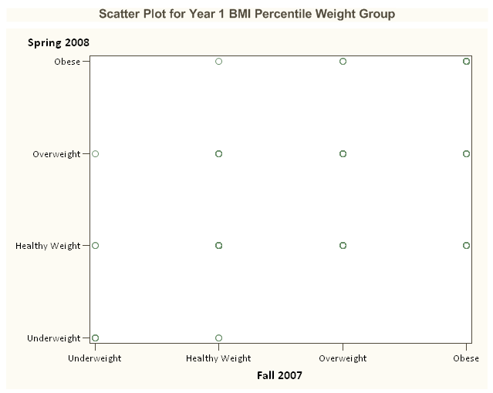
107
7
1
14
28
5
2
1
2
15
3
10
8

Year 2

- There were 248 students who had matched BMI scores between Fall 2008 and Spring 2009.
- A statistically significant increase occurred in BMI percentile scores during Year 2 (t-test = -3.87, p-value = 0.0001).
- However, when grouped into weight categories, no statistical significance was found (t-test = 1.37, p-value = 0.1872)
- The scatter plot to the right shows the number of students by weight category.
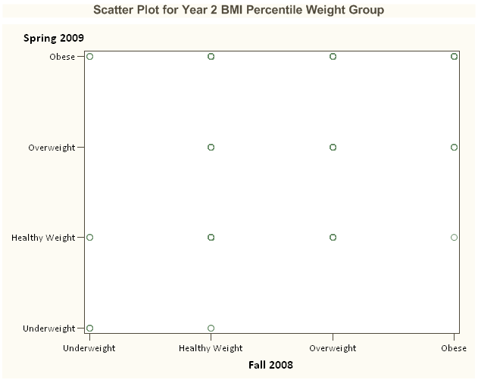
3
1
19
32
3
2
4
39
5
24
15
12
89

Year 3

- There were 191 students who had matched BMI scores between Fall 2009 and Spring 2010.
- A statistically significant decrease did occur in BMI percentile scores during Year 3 (t-test = 1.85, p-value = 0.0652).
- When grouped into weight categories, a statistical significance was not found (t-test = -1.80, p-value = 0.0741)
- The scatter plot to the right shows the number of students by weight category.
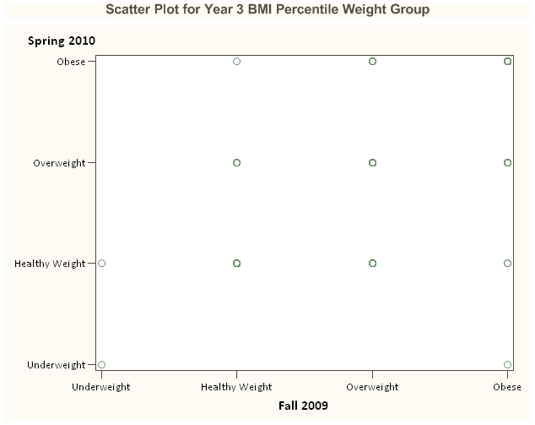
103
5
12
23
8
28
1
1
1
1
6
2

Obese
Overweight
Healthy Weight
Note: Average BMI for Individuals was not significant by age group.

